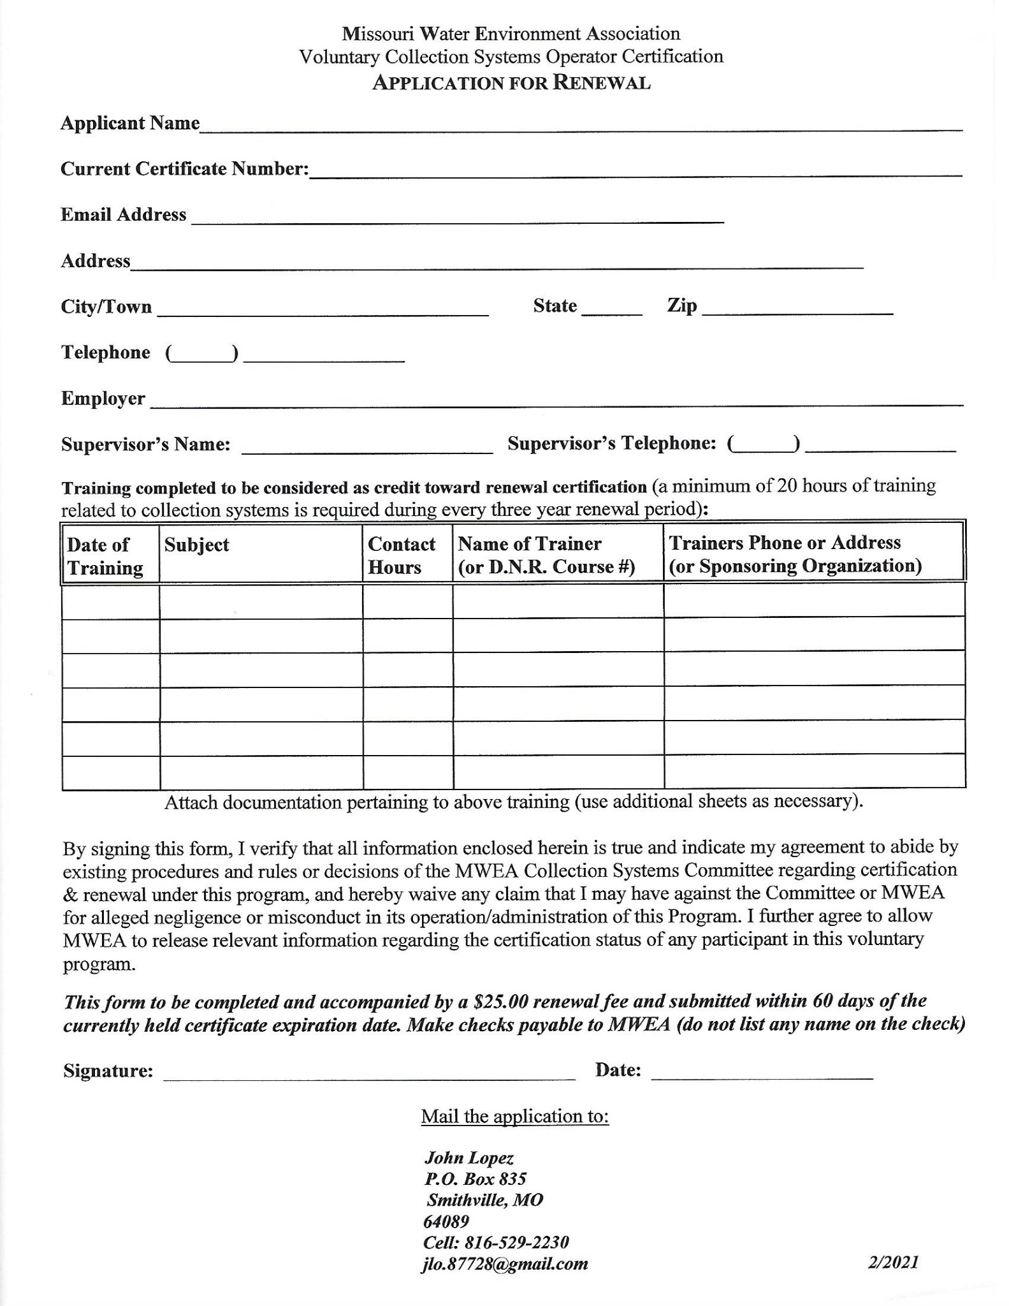
Ryan Poertner
Ace Pipe Cleaning, Inc.
4410 Hunt Ave
St Louis, MO 63110
rpoertner@acepipe.com
314-368-1574

