Missouri Water Environment Association Collection Systems Committee
Voluntary Collection Systems Operator Certification
APPLICATION FOR EXAMINATION

Exam Date _______________ Location __________________________________________________ Time ______________
Applicant Name_____________________________________________________________________________________________
(Please print clearly the name you would want on your certificate)

Address ____________________________________________________________________________________________________

City/Town _________________________________________ State ________ Zip Code ___________________
Telephone (______) _______________________ Applicant Email address ___________________________________________

Employer _______________________________________________ Work Email ______________________________________
Supervisor’s Name ______________________________ Supervisor’s Telephone (______) _____________________________
Certification Level Sought (circle one) A (min. 6 yrs.) B (min. 4 yrs.) C (min. 2 yrs.) D (min. 6 mos.)
Experience: (describe Collection System experience; additional experience may be provided on attached sheet, if necessary)
EMPLOYER | CITY | STATE
POSITION |  | YEARS
DUTIES
EMPLOYER | CITY | STATE
POSITION |  | YEARS
DUTIES
By signing this form, I verify that all information enclosed herein is true and indicate my agreement to abide by testing
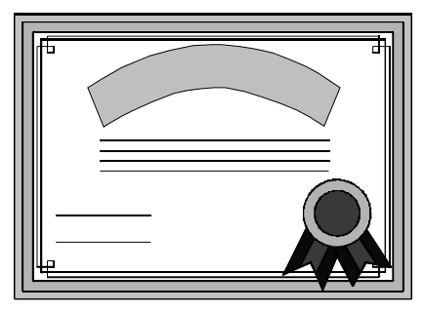
procedures and rules or decisions of the MWEA Collection Systems Committee regarding certification under this program, and hereby waive any claim that I may have against the Committee or MWEA for alleged negligence or misconduct in its operation/administration of this Program. I further agree to allow MWEA to release information regarding the status of any participant in this voluntary program. Accommodations may be provided for persons with disabilities or physical handicaps. Requests for such must be submitted in writing with this application.

This form to be completed and accompanied by a $25.00 non-refundable application fee. Signature: _________________________________________Date: _____________ Make checks payable to “MWEA” and mail with application to the MWEA Collection Systems Committee Registrar:
John Lopez
P.O. Box 835
Smithville, MO
64089
Cell: 816-529-2230
jlo.87728@gmail.com

